Name:_____________________________________________________________________________Period:__________
Exposure to toxic metal can lead to devastating effects
By Chicago Tribune, adapted by Newsela staff -7
CHICAGO, Ill. — After growing up poor in a mostly African-American neighborhood of Cincinnati, the young adults had reached their early 20s. One by one, their brains were scanned in a hospital.
Those who had been exposed to lead as toddlers had experienced permanent and devastating changes.
The toxic metal had robbed them of gray matter. It is the substance in the brain that enables people to pay attention, regulate feelings and control impulses. Lead also had scrambled the production of white matter that transmits signals between different parts of the brain.
The young adults were participants in a study at the University of Cincinnati. The study showed that scars left by lead have had a significant effect on the young people and their communities. As children, they struggled in school more than those who had not been exposed. As teens, they committed crimes more frequently.
“Lead sowed the seeds of their future,” said Kim Dietrich, a neuropsychologist who has been following the group of nearly 300 people since they were born in the late 1970s.
Lead Continues To Harm Children
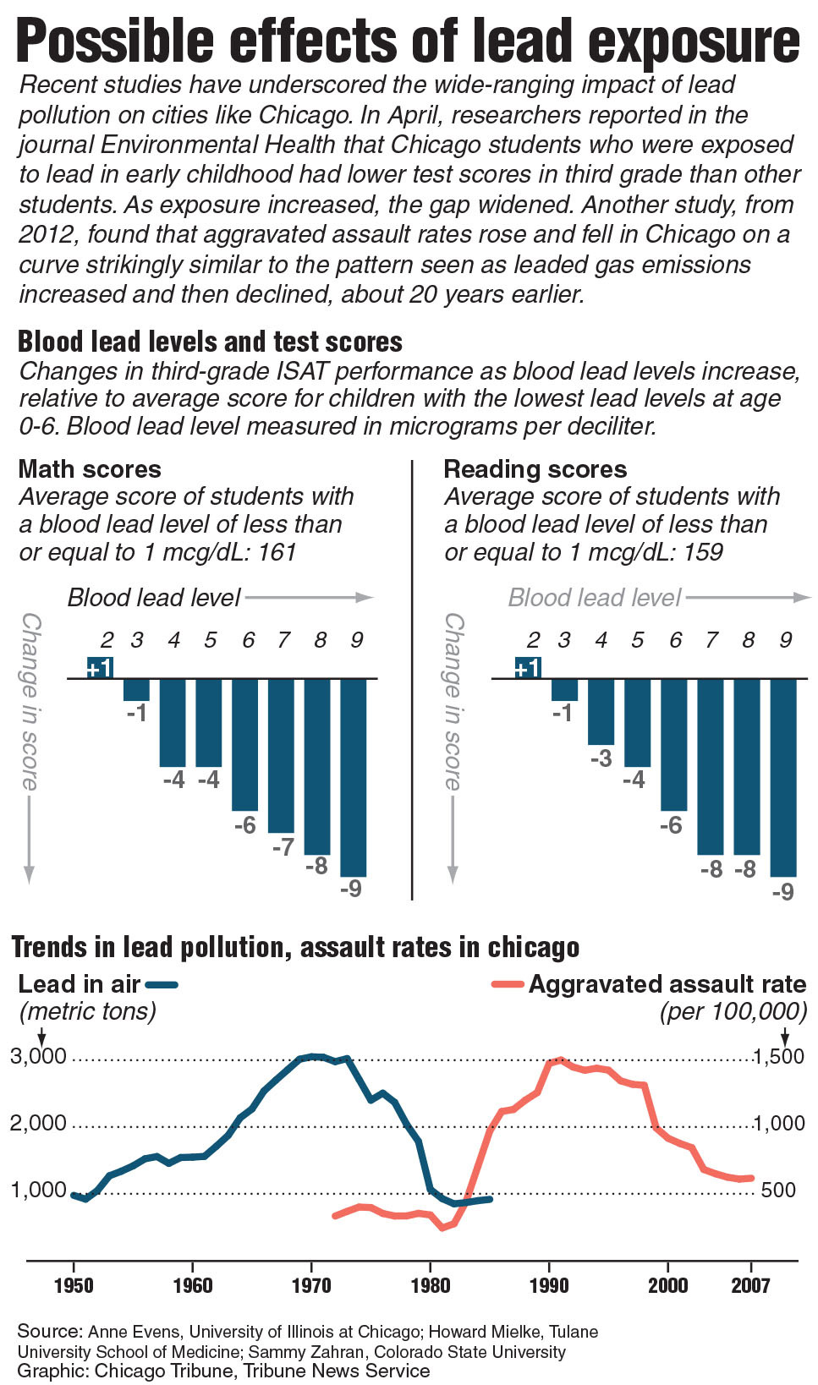
She said that lead is a barrier to "normal development, making smart decisions and success.”
People have known for centuries that lead is poisonous. Removing it from gasoline and paint has dramatically reduced exposure for American children.
Yet lingering dust from paint and deposits from old vehicle emissions continue to harm thousands of children in older industrial cities like Cincinnati and Chicago.
Early exposure harms children in ways that don't show up until years later. Money has to be spent on health care, special education and law enforcement.
Lead Is A Problem In Poor, Crime-Ridden Neighborhoods
Last month, an investigation by the Chicago Tribune newspaper found that lead is a major problem in poor neighborhoods with a lot of crime. In 1995, the children in these neighborhoods were tested. More than 80 percent of them had dangerous lead levels.
Today those children are in their early to mid-20s, when criminal behavior peaks.
There is more and more evidence of links between lead poisoning, poor school performance and crime. Some scientists are starting to focus on lead pollution as a key factor in Chicago’s violence.
Robert J. Sampson is a Harvard University researcher who has been studying Chicago for more than 20 years.
Sampson recently added information on lead to his research on poverty, education and crime in Chicago neighborhoods. A map of lead poisoning rates among children younger than 6 in 1995, for instance, looks very similar to a map of assault rates in 2012, when those children were 17 to 22 years old.
He said these "astounding levels of lead poisoning" are part of the cycle of poverty that keeps people trapped in poverty for generations.
Many Leaders Thought Problem Was Solved
People who make laws seem to regard lead pollution as a problem solved long ago. During the past five years, national and state leaders have cut the amount of money spent to screen children, inspect buildings and get rid of lead.
Children ages 5 and younger are the ones suffering more than anyone else. Many of these children live in neighborhoods that are mostly African-American.
Another study looked at the lead tests of thousands of children born in Chicago from 1994 to 1998. The researcher who did the study is named Anne Evens. She compared the results with how the children performed on standardized tests in third grade.
Her study found that being around lead during early childhood increased the chance that a student would fail reading and math tests. This was true even when controlling for other factors such as poverty, race, birth weight and the mother’s education level.
Study Results Are Shocking
What Evens found is shocking: At three-quarters of Chicago Public Schools, the average lead level of third-graders was higher than what the government says is safe.
Why is third grade so important? That’s when children begin to use reading to learn other subjects, and studies show students who fail to master reading skills during such a critical year are more likely to fall behind in later grades and drop out of high school. Dropouts are much more likely to end up in jail than to ever graduate.
Some people know that children exposed to lead as toddlers are more likely to act out. They also have trouble staying on task and they struggle to work well with classmates.
The link between childhood lead exposure and violent behavior is well-established, both in animal research and human studies. Small doses can reduce IQ. They can also cause parts of the brain to temporarily stop working, in particular the areas that help control violent behavior.
“Of all the problems that affect kids in these neighborhoods, lead is the easiest to solve,” Evens said.
1. Select the sentence that is LEAST important to include in the summary of the section "Lead Continues To Harm Children."
(A) Emission from old vehicles exposes children to lead.
(B) Gasoline and paint used to have large amounts of lead.
(C) Lead is not favorable for the normal development of a child.
(D) The effects of lead poisoning do not show up until years later.
2. Select the sentence from the section "Lead Is A Problem In Poor, Crime-Ridden Neighborhoods" that BEST supports the central idea of the article.
(A) Today those children are in their early to mid-20s, when criminal behavior peaks.
(B) Some scientists are starting to focus on lead pollution as a key factor in Chicago’s violence.
(C) Sampson recently added information on lead to his research on poverty, education and crime in Chicago neighborhoods.
(D) He said these "astounding levels of lead poisoning" are part of the cycle of poverty that keeps people trapped in poverty for generations.
3. Which answer choice BEST describes the article's structure?
(A) a discussion of the various effects of lead poisoning
(B) an analysis of the types of cities where lead poisoning is found
(C) a discussion of the connection between lead poisoning and crime
(D) an analysis of the studies on the effects of lead poisoning
4 How does paragraph 1 of the section "Many Leaders Thought Problem Was Solved" fit in the overall structure of the article?
(A) It highlights how mistaken the leaders are about the problem of lead pollution.
(B) It shows that lawmakers had solved the issue of lead pollution a long time ago.
(C) It highlights the amount of resources that leaders have used to keep lead pollution under control.
(D) It shows that lead pollution persists because leaders are not trying to get rid of lead anymore.

