Density Practice Problems Homework
Due Date: _________
Name:_________________________________________________________________Period:____________
Remember to:
- Include units in your answer.
- Show all work.
- Circle answer
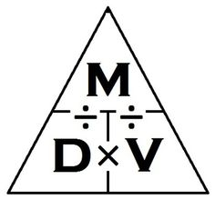
1) A block of aluminum occupies a volume of 15.0 mL and weighs 40.5 g. What is its density?

2) Mercury metal is poured into a graduated cylinder that holds exactly 22.5 mL. The mercury used to fill the cylinder weighs 306.0 g. From this information, calculate the density of mercury.

3) What is the weight of the ethyl alcohol that exactly fills a 200.0 mL container? The density of ethyl alcohol is 0.789 g/mL.

4) A rectangular block of copper metal weighs 1896 g. The dimensions of the block are 8.4 cm by 5.5 cm by 4.6 cm. From this data, what is the density of copper?

5) A flask that weighs 345.8 g is filled with 225 mL of carbon tetrachloride. The weight of the flask and carbon tetrachloride is found to be 703.55 g. From this information, calculate the density of carbon tetrachloride.

6) Calculate the density of sulfuric acid if 35.4 mL of the acid weighs 65.14 g.

7) Find the mass of 250.0 mL of benzene. The density of benzene is 0.8765 g/mL.

8) A block of lead has dimensions of 4.50 cm by 5.20 cm by 6.00 cm. The block weighs 1587 g. From this information, calculate the density of lead.

9) 28.5 g of iron shot is added to a graduated cylinder containing 45.50 mL of water. The water level rises to the 49.10 mL mark, from this information, calculate the density of iron.

10) What volume of silver metal will weigh exactly 2500.0 g. The density of silver is 10.5 g/cm3.

